 | ® Top-of-Car Guardrails
800-328-7840
Email Survey to info@unitecparts.com

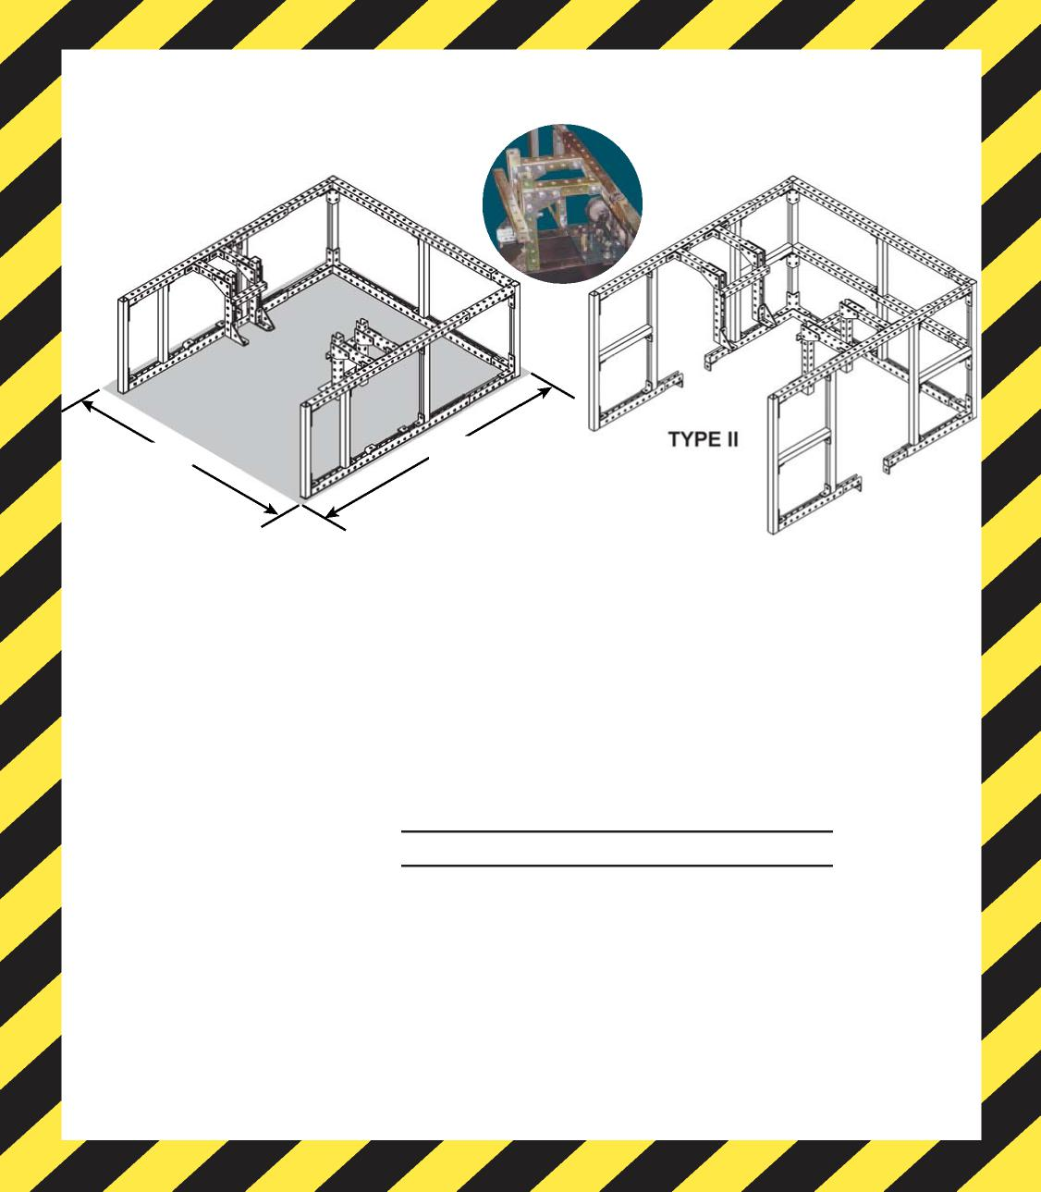
Top-of-car guardrails reduce the potential for falling off the car top and is standard protection on most new elevators (ASME 2000-2.14.1.7; 2.10.2).
NOTE: The new kits are specifically designed to assemble to current production
carframes. When applying these handrails to older or non-Otis elevator
systems, additional on-site customization will likely be necessary.
Front or Front/Rear
Dimensions
Car Width (in.):

Car Depth (in):
If for Otis equipment, complete the following section:

How SAFE is the guardrail on top of YOUR elevator cab?
Top-of-Car Guardrail Kits from UNITEC
Cab
Width
Top of Cab
TYPE I
Cab Depth
SURVEY FORM

Roller Guide Size (in): 10 in., 7-7/8 in.
Car Frame Type: 9C, 11C, 12C, 12D, 18D, 25D
Please type in size:

Please type in car frame type:

.

.
UNITEC PARTS COMPANY | Phone: 1 800 328 7840 | Fax: 860 286 1625 | www.unitecparts.com REV 1/16

