Oil-Gas Return Buffers
Approved Replacement for all obsolete Otis early vintages

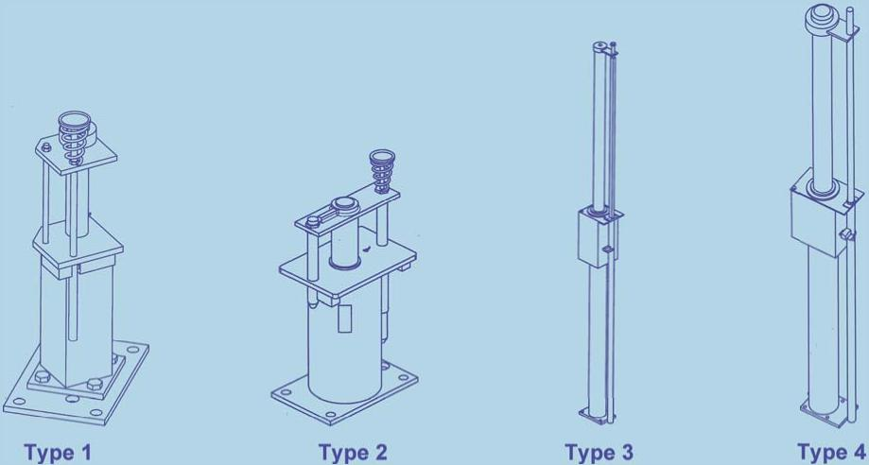
Buffer Type | Part No. | Stroke Range | Load
1 & 2 | AAA6136BE_ _ | 8.6" - 17.13" | Up to 18.3k lb.
1 & 2 | AAA6136BE_ _ | 11.8" - 45" | Up to 18.3k lb.
3 | AAA6136BE54  AAA6136BE35 | 68.5" & 83" | 16.5k lb.
4 | AAA6136BE36 | 98.6" | 22k lb.
All new buffers are equipped with buffer switches. Buffers are shipped without oil. To order buffer oil, use part number VP-418935 or VP-419805 (for heavy duty).
SURVEY
All fields must be completed to ensure an accurate buffer quote.
Existing Overall Buffer Existing Buffer Stroke:

Length:
Elevator Rated Speed:

Car or CWT Striking Speed (see NOTE):

Present Striking Load or Buffer Load Rating:

Is reduced stroke buffer condition present:

NOTE: Car or CWT striking speed may be less than elevator rated speed.
Email Survey to info@unitecparts.com

UNITEC PARTS COMPANY | Phone: 1 800 328 7840 | Fax: 1 860 286 1625 | www.unitecparts.com
Rev. 1/16

