**Folding Door Restrictor**

**Field Survey_________________________________________________**

**NOTE:** Use one survey sheet per car, unless all dimensions and landing configurations are the same.

* The table should have one more measurement for Entrance Heights than there are Hoistway Floor Heights.
* Above 20 floors, contact Unitec® for restrictor options. If job has rear entrances, contact Unitec® directly.

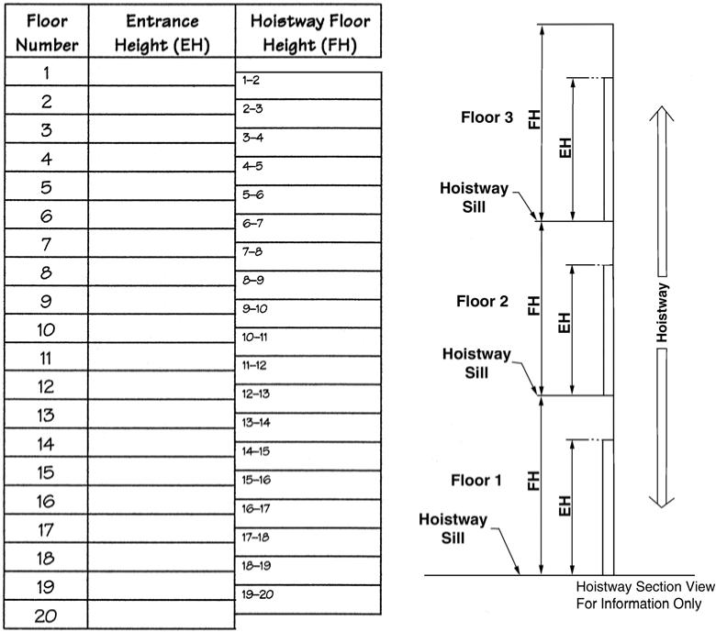

|  |  |  |
| --- | --- | --- |
| Floor Number | Entrance Height (EH) | Hoistway Floor Height (FH) |
| 1 |  | 1-2 |
| 2 |  | 2-3 |
| 3 |  | 3-4 |
| 4 |  | 4-5 |
| 5 |  | 5-6 |
| 6 |  | 6-7 |
| 7 |  | 7-8 |
| 8 |  | 8-9 |
| 9 |  | 9-10 |
| 10 |  | 10-11 |
| 11 |  | 11-12 |
| 12 |  | 12-13 |
| 13 |  | 13-14 |
| 14 |  | 14-15 |
| 15 |  | 15-16 |
| 16 |  | 16-17 |
| 17 |  | 17-18 |
| 18 |  | 18-19 |
| 19 |  | 19-20 |
| 20 |  |  |

**Please complete:**

Customer Information:

Name: Phone Number:

Company Name: Email Address:

Account Number: Job Name:

Elevator Information:

Opening Type: Number of Cars:

Center-Opening Number of Landings per Car:

Single-Slide Number of Front Entrances:

Two-Speed Number of Rear Entrances:

If you have Otis type 6940 door locks, provide length of car vane (cam) on the car door:

**Email Survey to** [**info@unitecparts.com**](mailto:info@unitecparts.com) **or fax back to: (860) 286-1625**